Directions to Fayette Evening High School

From Interstate 85 (North Atlanta):

Exit I-85 at Riverdale Road Exit. Make a left at the light (at the end of the exit ramp). At the second light, turn right onto Fayetteville Road/GA Highway 314. Stay on GA 314 until reaching the intersection of GA Highway 85 (N. Glynn Street). This is a well marked intersection with a traffic light. Stay in the right hand lane and bear right at this intersection (yield sign). T&G Allsports will be on the right. Remain on GA 85 and watch for the Arby's restaurant on your right. Turn right immediately past the Arby's property onto LaFayette Avenue. We are located on your right-hand side.

IF YOU MISS THE TURN AT ARBY'S, continue one block to the stoplight. (GA 54 splits here with three lanes going east and three lanes going west separated by a city block.) Turn right onto GA 54, then take your first right onto Tiger Trail. Go one block to the stop sign at LaFayette Avenue. Turn right and then left into the first driveway. Our building is the building that is directly in front of this drive way.

From Interstate 85 South (Newnan, LaGrange, etc.):

Exit I-85 at Peachtree City GA Highway 74 Exit. Make a right at the end of the exit ramp traveling toward Peachtree City. At the intersection of GA 85 and GA 54 make a left onto GA 54. Remain on GA 54 traveling through Peachtree City and into Fayetteville. Watch the speed limit signs. Speed will reduce to 35 mph as you enter Fayetteville. Highway 54 will split with an island between the east and westbound lanes. Immediately past this split, turn left onto Tiger Trail. Go one block; cross Hwy. 54 westbound. Go another block to LaFayette Avenue. Turn right and then left into the first driveway. Our building is the building that is directly in front of this drive way.

From Interstate 75 Southbound (Farmer's Market, Riverdale, etc.):

Exit I-75 onto GA Highway 85/Farmer’s Market Exit. Stay on GA 85 southbound. You will travel through Riverdale and Pointe South before reaching Fayetteville. Remain on GA 85. There will be four traffic lights once you enter Fayette County. The first light is at the Fayette Pavilion Shopping Complex (Home Depot), the second at the intersection of GA 314 and GA 85, the third at GA 92 North and GA 85 and the fourth at GA 54 and GA 85. Between the 3rd and 4th lights, you will see an Arby's restaurant on your right. Turn right immediately past the Arby's property onto LaFayette Avenue. We are located on your right-hand side.

IF YOU MISS THE TURN AT ARBY'S, continue to the fourth stoplight. (GA 54 splits here with three lanes going east and three lanes going west separated by a city block.) Turn right onto GA 54, then take your first right onto Tiger Trail. Go one block to the stop sign at LaFayette Avenue. Turn right and then left into the first driveway. Our building is the building that is directly in front of this drive way.

From Interstate 285 East or Westbound:

Exit Interstate 285 at the GA Highway 85 Exit. You will travel south on GA 85 through Riverdale and Pointe South before reaching Fayetteville. There will be four traffic lights once you enter Fayette County. The first light is at the Fayette Pavilion Shopping Complex (Home Depot), the second at the intersection of GA 314 and GA 85, the third at GA 92 North and GA 85 and the fourth at GA 54 and GA 85. Between the 3rd and 4th lights, you will see an Arby's restaurant on your right. Turn right immediately past the Arby's property onto LaFayette Avenue. We are located on your right-hand side.

IF YOU MISS THE TURN AT ARBY'S, continue on to the fourth stoplight. (GA 54 splits here with three lanes going east and three lanes going west separated by a city block.) Turn right onto GA 54, then take your first right onto Tiger Trail. Go one block to the stop sign at LaFayette Avenue. Turn right and then left into the first driveway. Our building is the building that is directly in front of this drive way.
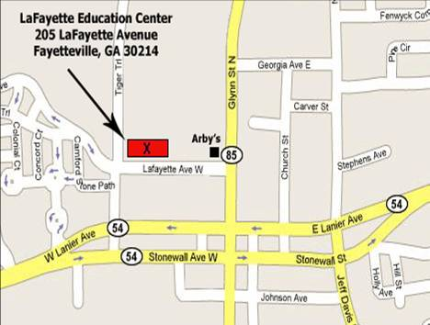
Aerial View of The LaFayette Education Center/Evening High School

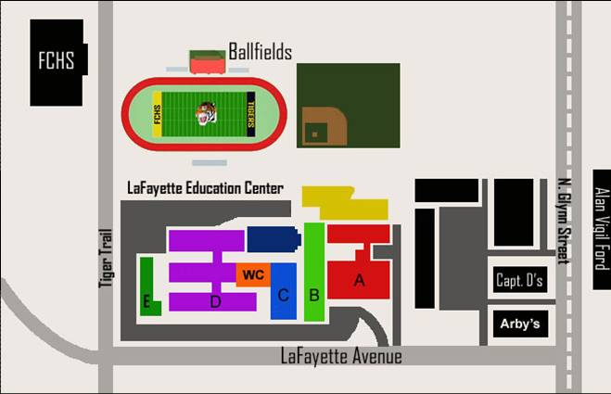

Fayette Evening High School

